CO3 AT2 Case Study
CSA0603 - Design and analysis of algorithm
Name: S Priyanka Reg no:192424033

Title
Airline Reservation Sorting System Using Merge Sort

Description of the Real-World Problem
Airline reservation systems handle thousands of flight bookings every day. These bookings need to be sorted based on departure time and passenger priority (such as VIP or Business Class). Fast and accurate sorting helps airlines manage boarding, scheduling, and customer service efficiently.

Problem Statement
Design an airline reservation sorting system that efficiently sorts flight bookings according to departure time while maintaining the order of bookings with the same departure time. The system should handle a large number of records and provide efficient performance.

Algorithm Used:
Merge Sort (Divide and Conquer)
Algorithm Steps:
- Divide the booking list into two equal halves.
- Continue dividing until each sublist contains one booking.
- Compare bookings based on departure time.
- Merge the sorted sublists into one sorted list.
- Repeat until the entire list is sorted.

Justification for Choosing the Algorithm (Why Merge Sort?)
- Stable sorting algorithm (maintains the order of equal departure times).
- Efficient for large datasets.
- Guaranteed O(n log n) time complexity.
- Suitable for airline reservation databases where accuracy is important.
- Works well for linked lists and external storage.

Complexity Analysis
Case | Time Complexity
Best Case | O(n log n)
Average Case | O(n log n)
Worst Case | O(n log n)
Space Complexity | O(n)

Manual Execution (Step-by-Step Process)
Sample Input
Flight | Departure Time
AI305 | 10:30
AI101 | 08:15
AI220 | 09:45
AI450 | 11:00
Step 1: Divide
[AI305, AI101] [AI220, AI450]
Further divide:
[AI305] [AI101] [AI220] [AI450]
Step 2: Merge
Compare:
AI305 (10:30) and AI101 (08:15)

Result:
[AI101, AI305]
Compare:
AI220 (09:45) and AI450 (11:00)

Result:
[AI220, AI450]
Step 3: Final Merge
Compare all:
08:15 → AI101
09:45 → AI220
10:30 → AI305
11:00 → AI450
Final Output
Flight | Departure Time
AI101 | 08:15
AI220 | 09:45
AI305 | 10:30
AI450 | 11:00

Applications
- Airline reservation systems
- Railway ticket booking systems
- Hospital appointment scheduling
- Online shopping order processing
- Banking transaction sorting

Advantages
- Stable sorting algorithm.
- Efficient for large datasets.
- Predictable O(n log n) performance.
- Suitable for external sorting.
- Produces accurate and reliable results.

Limitations
- Requires extra memory O(n).
- Slower than Quick Sort for small datasets.
- Recursive implementation increases memory usage.

Comparison with Other Algorithms
Algorithm | Best | Average | Worst | Stable
Merge Sort | O(n log n) | O(n log n) | O(n log n) | Yes
Quick Sort | O(n log n) | O(n log n) | O(n²) | No
Bubble Sort | O(n) | O(n²) | O(n²) | Yes
Selection Sort | O(n²) | O(n²) | O(n²) | No
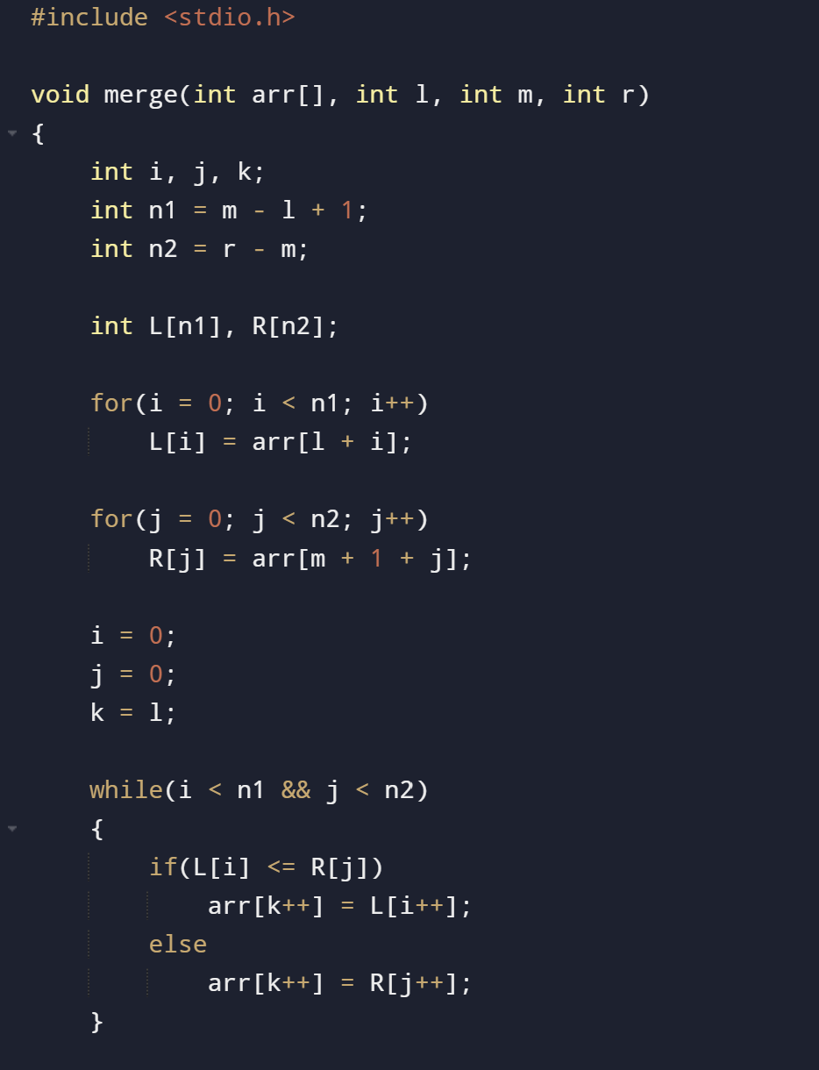
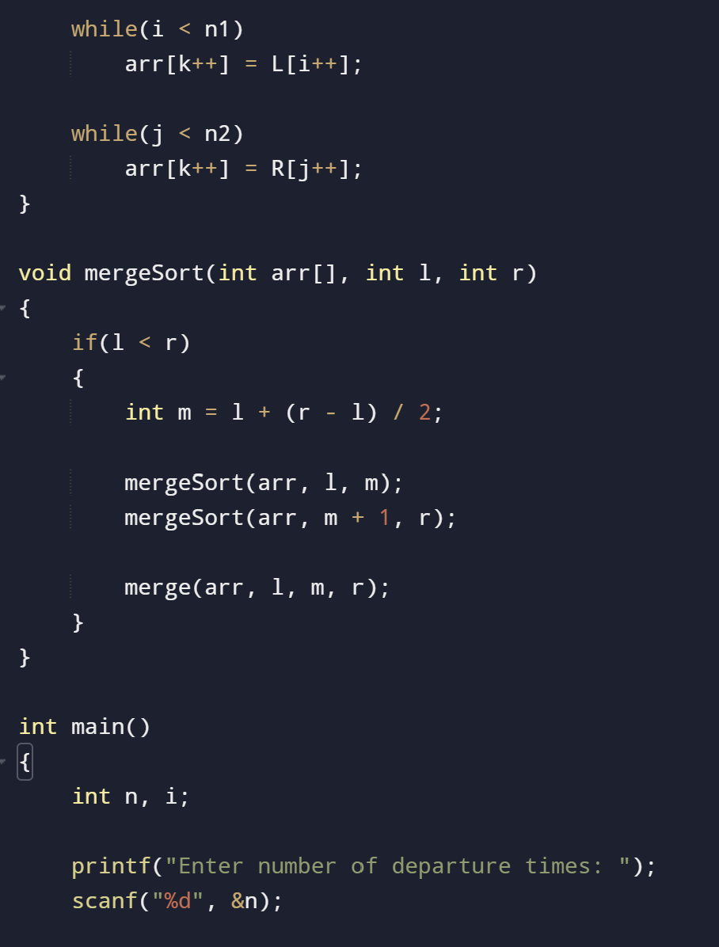
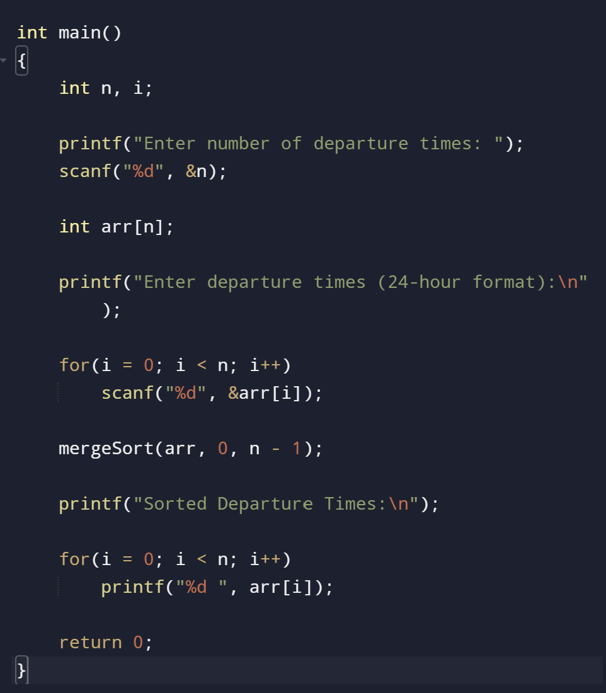

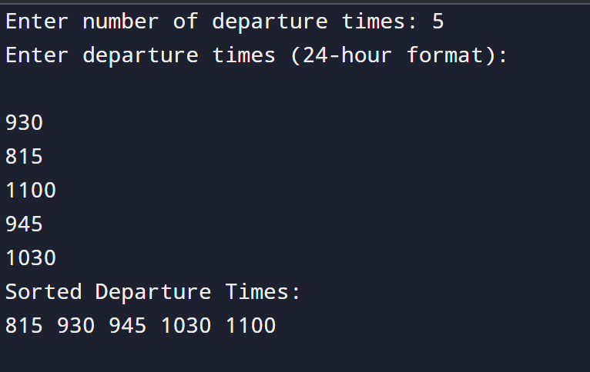

Conclusion
Merge Sort is an efficient and stable sorting algorithm for airline reservation systems. It handles large booking records efficiently using the divide-and-conquer approach and guarantees O(n log n) time complexity in all cases. Its stability ensures that bookings with the same departure time retain their original order, making it a reliable choice for real-world airline reservation management.

